**CS 341 – Lab 9**

**A Low Cost Frequency Meter**

In this lab, you will learn about waveforms. In part 1 you will observe the operations of a function generator with an oscilloscope to understand the relationship between frequency, and period. In part 2 you will create a frequency meter that calculates the frequency and period of an incoming signal. The starter code can be on my [github](https://github.com/whittyh/cs341) under cs341/lab_9.

Background Information

This lab is based on an article “*A simple, low cost, precision frequency meter uses only two pins of a PC parallel port*” written by Radovan Stojanovic published in the Design Ideas section of the EDN magazine. The setup is shown in figure 1:

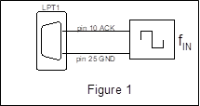

The computer runs a program that reads the state of pin 10 of the line printer port (LPT1). By measuring the time when the pin is high and the time when pin is low as shown in figure 2,

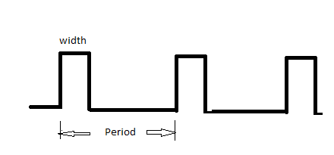

the program computes the pulse width and the period. The frequency of the square wave generator fIN is calculated using:

frequency = 1 / Period

In this lab, we will program the computer to read the state of an I/O pin that is connected to a function generator. The pulse width is measured using a polling method (we keep checking in a while loop) to determine if the state of the I/O pin has changed using the following pseudo code:

get the current_time_1;

here: if pin is high, loop here;

get the current_time_2;

width= current_time_2 – current_time_1;

You can modify the above logic to obtain the duration when the level is low. The period is obtained by adding the pulse width (the length of time the pin was high) and the duration when the I/O pin is low.

Part 1

In part 1, we are going to observe the operations of the function generator with the oscilloscope. The function generator outputs a signal in a wave (you can imagine the graph y = sin x), and the oscilloscope displays it. They should be connected like this:

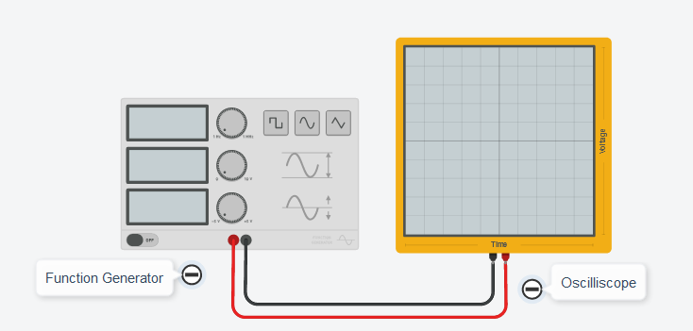

On the oscilloscope, the only setting we can change is the scale of the x-axis. The settings on the function generator work as follows:

Frequency: how many times the wave will be repeated in 1 second

Amplitude: the difference in voltage between the top of the wave and the bottom of the wave

DC Offset: the voltage amount that the wave is centered at

Function: change between rectangular, smooth, or triangular wave

Setup the function generator with frequency 1Hz, amplitude 5V, offset 2.5V, and function set to square. Now try changing the oscilloscopes scale so that you can see a few waves (try 200ms if you are completely lost). You should see something like this.

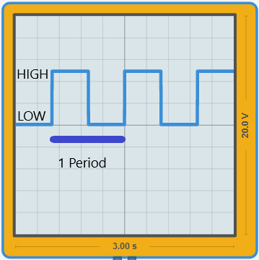

Try changing the frequency and look at the resulting change in the period. Does the period grow longer or shorter?

Part 2

In part 2, you will be writing a program that reads a signal from a function generator and calculates the frequency and period. Since the lab does not have many function generators, you will build a square wave generator using a 555 timer chip as shown below:

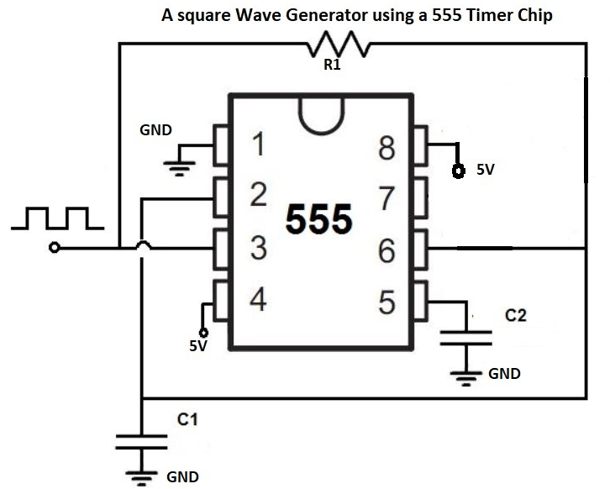

The pulse width of the square wave is controlled by the capacitors C1, C2 and the resistor R1. With C1= 104nF, C2= 104nF and R1 =220 K ohms, the 555 timer generates a square wave with 50ms high and 35 ms low. You can verify the time durations of the 555 generator using the oscilloscope.

Connect pin 3 of the 555 square wave generator to pin 10 of the Arduino; 5V and GND of the generator to that of the Arduino respectively as shown below:

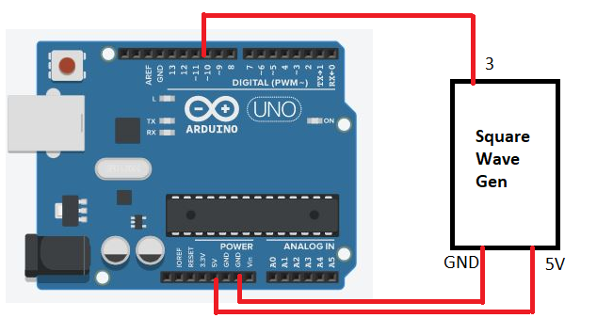

Using the method described in the background section, measure the duration when the signal in pin 3 is high and the duration when the signal is low. Then calculate the frequency and period of the square wave. Pay close attention to the pseudocode on page 2, and the comments in the starter code. Also, be aware that the micros() function returns a result in microseconds.

Lab Report

You can submit your lab report by leaving them in a lab_9 directory on the linux serverss